Thermal Energy and Changes of State WS

Directions: In each example below, state whether energy is being lost or absorbed.

1.

2. 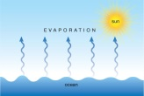
3. 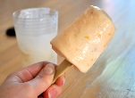

4. 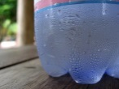

Directions: Complete the table by listing the new state of matter and the process the matter underwent.
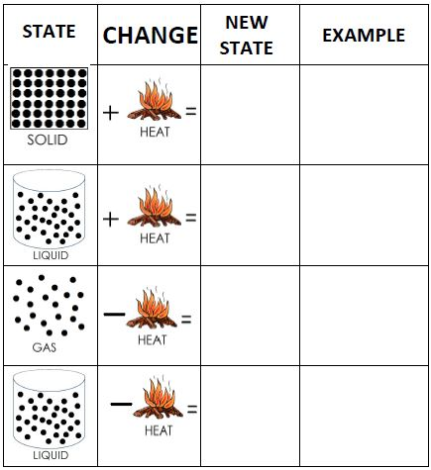
PROCESS

